RPE Charge Rule Engine Microservice - Solution Proposal

1. Key Benefits
Decouple RPE from the legacy STS charge service
Provide low-latency charge calculation within RPE
Support GBPS-generated charge rules
Enable scalable microservice-based rule execution
Provide full rule audit and traceability

2. System Context
IBANK send payment requests to RPE. RPE calls the Charge microservice to calculate the applicable charge before transaction confirmation. GBPS remains the rule management and actual charge calculation system.

3. High Level Architecture
Components:
- Rule Loader
- Rule Processor
- Rule Index Builder
- In-Memory Rule Cache
- Rule Selection Engine
- Charge Calculator
- Rule Execution Logger

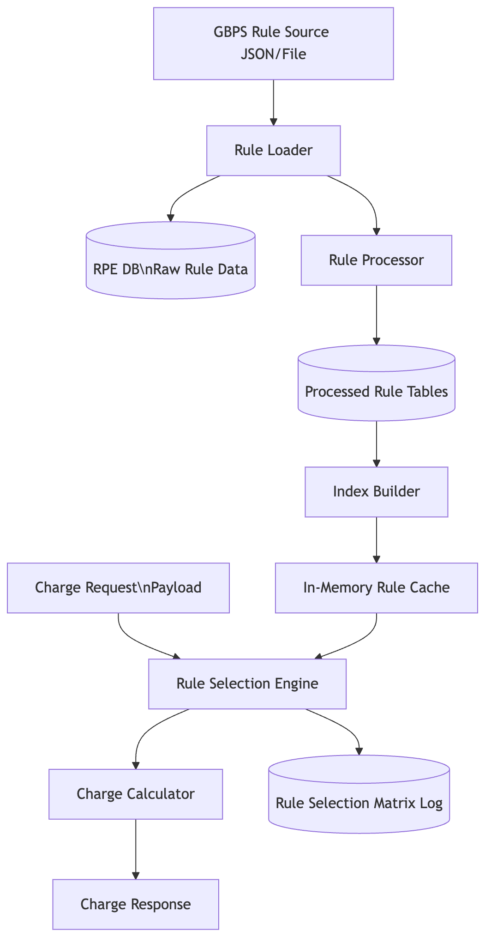

4. Rule Data Flow
Receive rule data from GBPS (JSON or file format)
Store raw rule payload in RPE database for audit
Process rule expressions and extract conditions
Generate rule indexes
Load rules into in-memory cache
Evaluate rules during charge calculation

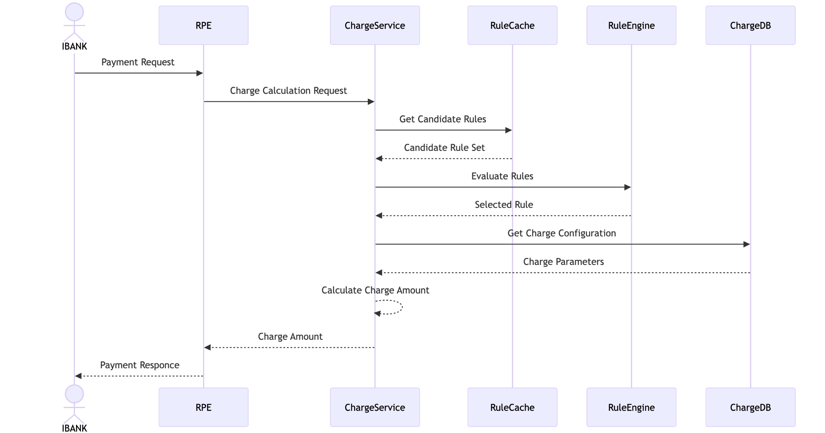

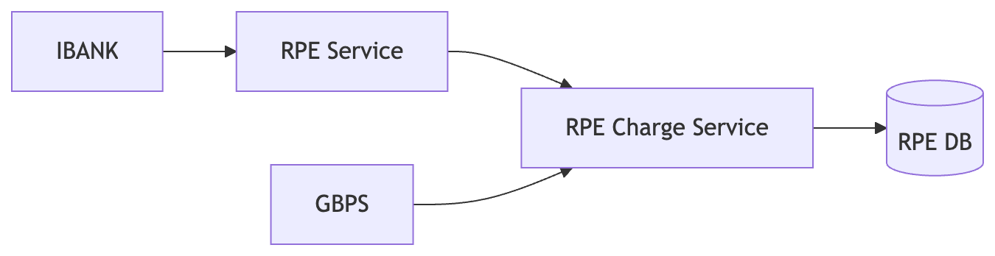

5. Database Design

6. Rule Index Strategy
Example index structure:
index["header.pmtTp"]["TT"] → [R1, R4, R8]
index["header.pmtTp"]["LT"] → [R2, R5]
index["header.pmtTp"]["BT"] → [R3]
index["header.pmtTp"]["N/A"] → [R6, R7]

7. Rule Selection Algorithm
1. Extract candidate parameters from payload
2. Lookup indexed rules
3. Combine indexed rules with generic rules
4. Evaluate rules using short-circuit logic
5. Return first matching rule

8. Performance Strategy
Without indexing: 100 rules × 20 conditions = 2000 checks.
With indexing and short-circuit evaluation: ~50–200 checks.

9. Rule Evaluation Logic
AND conditions stop evaluation on first failure.
OR conditions stop evaluation on first success.

10. Rule Update Strategy
Initial Load: full rule load from GBPS.
Incremental Updates: only updated rules processed.
Cache reload performed atomically.
Manual endpoint: POST /admin/rules/reload.

11. Microservice Design
Single Spring Boot microservice with internal components:
API Controller
Charge Service
Rule Loader
Rule Parser
Rule Index Builder
Rule Cache
Rule Engine
Charge Calculator

12. Rule Execution Logging
Table: RPE_RULE_EXECUTION_LOG
Columns: request_id, rule_id, rule_priority, execution_time, evaluation_result, timestamp

13. Deployment Model
Stateless microservice deployed in multiple instances behind a load balancer. Each instance maintains its own in-memory rule cache.

14. Migration Strategy
Phase 1: Run STS and new service in parallel
Phase 2: Compare outputs
Phase 3: Switch traffic to new service
Phase 4: Decommission STS

15. Risks and Mitigation
Rule complexity → structured rule engine
Large rule sets → indexing and caching
Rule updates → atomic cache reload

16. Non-Functional Requirements
Latency < 10ms
Availability 99.99%
Throughput ~5000 TPS

